As our textbook (Marsic, 2010) describes it, a Cellular Network Backhaul connects the nodes of a network. For example, in the case of wireless cell phones, the backhaul would be the mobile switching center and is often the bottleneck for cell traffic (Marsic, 2010). Another definition given for the backhaul network is everything between the cell site and the mobile core (RCR Wireless News, 2014). An article that I read on the topic suggests that the backhaul has traditionally been thought of in terms of information transfer. That is, cell tower signals are hauled or transported to points of interest so that quality of service can be applied (RCR Wireless News, 2014). A very helpful diagram aimed at hotspot improvements, gives us an idea for scope for what the backhaul entails: From major network cores to smaller cell spots dedicated to a portion of the overall network, the backhaul is what provides data to individual devices (Ericsson white paper, 2014).

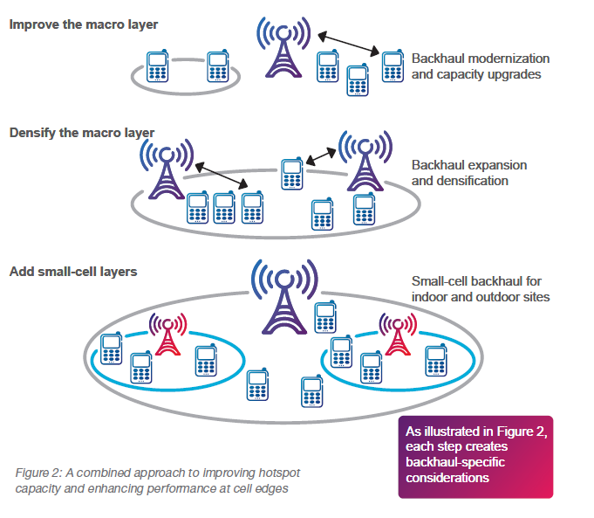

References

Ericsson white paper (2014). It All Comes Back to Backhaul. Retrieved from <http://www.ericsson.com/res/docs/whitepapers/WP-Heterogeneous-Networks-Backhaul.pdf>

Marsic, I. (2010). Computer Networks: Performance and Quality of Service. Retrieved from http://www.ece.rutgers.edu/~marsic/books/QoS/

RCR Wireless News (2014). Backhaul Basics, A DefinitionNetwork Experts Define Backhaul Networks. Retrieved from <http://www.rcrwireless.com/20140513/wireless/backhaul-network-definitions-cellular-backhaul-definition>